# Lab 16 – Database Design and Queries: Schema Design and SQL Generation

Name: Mohd. Aadil Ashraf  
Roll No: 2403A51315  
Subject: AI Assisted Coding  
Batch: BTECH CSE B13  
Date: 23-10-2025

## AI-generated prompts

schema_generation_prompt: Generate SQL CREATE TABLE statements for a normalized relational schema for {system_name}. Include primary keys, foreign keys, and sensible constraints for common fields.

query_generation_prompt: Generate SQL queries to perform CRUD and analytics tasks: insert, select by foreign key, aggregation counts, and date-based filters for {system_name}.

testcase_prompt: Create at least 3 assert-style test cases (SQL or Python assertions) that verify correctness of the schema and queries for {system_name}.

## Task 1: Student Information System

**Schema:**

CREATE TABLE Students (  
 student_id INTEGER PRIMARY KEY AUTOINCREMENT,  
 name TEXT NOT NULL,  
 roll_no TEXT UNIQUE NOT NULL,  
 dob DATE,  
 year INTEGER,  
 major TEXT  
);  
CREATE TABLE Courses (  
 course_id INTEGER PRIMARY KEY AUTOINCREMENT,  
 code TEXT UNIQUE NOT NULL,  
 title TEXT NOT NULL,  
 credits INTEGER DEFAULT 3  
);  
CREATE TABLE Enrollments (  
 enrollment_id INTEGER PRIMARY KEY AUTOINCREMENT,  
 student_id INTEGER NOT NULL,  
 course_id INTEGER NOT NULL,  
 enrolled_on DATE DEFAULT (DATE('now')),  
 grade TEXT,  
 FOREIGN KEY(student_id) REFERENCES Students(student_id),  
 FOREIGN KEY(course_id) REFERENCES Courses(course_id),  
 UNIQUE(student_id, course_id)  
);

**Sample Inserts:**

INSERT INTO Students (name, roll_no, dob, year, major) VALUES ('Mohd Aadil Ashraf','2403A51315','2006-05-10',2,'CSE');

INSERT INTO Students (name, roll_no, dob, year, major) VALUES ('Neha Sharma','2403A50001','2005-02-20',2,'CSE');

INSERT INTO Courses (code, title, credits) VALUES ('CS101','Intro to CS',4);

INSERT INTO Courses (code, title, credits) VALUES ('MA101','Calculus I',3);

INSERT INTO Enrollments (student_id, course_id, grade) VALUES (1,1,'A');

INSERT INTO Enrollments (student_id, course_id, grade) VALUES (1,2,'B');

INSERT INTO Enrollments (student_id, course_id, grade) VALUES (2,1,'A');

**Queries:**

insert_new_student: INSERT INTO Students (name, roll_no, dob, year, major) VALUES ('Aman Verma','2403A59999','2006-01-01',1,'ECE');

fetch_courses_by_student: SELECT c.code, c.title FROM Courses c JOIN Enrollments e ON c.course_id = e.course_id JOIN Students s ON e.student_id = s.student_id WHERE s.roll_no = '2403A51315';

count_students_per_course: SELECT c.code, c.title, COUNT(e.student_id) as student_count FROM Courses c LEFT JOIN Enrollments e ON c.course_id = e.course_id GROUP BY c.course_id;

Index/Normalization suggestions (if any):

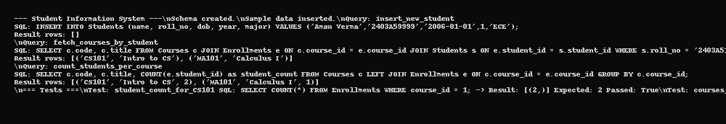

## Task 2: Hospital Management System

**Schema:**

CREATE TABLE Doctors (  
 doctor_id INTEGER PRIMARY KEY AUTOINCREMENT,  
 name TEXT NOT NULL,  
 specialization TEXT,  
 license_no TEXT UNIQUE NOT NULL  
);  
CREATE TABLE Patients (  
 patient_id INTEGER PRIMARY KEY AUTOINCREMENT,  
 name TEXT NOT NULL,  
 dob DATE,  
 patient_unique_id TEXT UNIQUE NOT NULL  
);  
CREATE TABLE Appointments (  
 appointment_id INTEGER PRIMARY KEY AUTOINCREMENT,  
 doctor_id INTEGER NOT NULL,  
 patient_id INTEGER NOT NULL,  
 appointment_date DATE NOT NULL,  
 notes TEXT,  
 FOREIGN KEY(doctor_id) REFERENCES Doctors(doctor_id),  
 FOREIGN KEY(patient_id) REFERENCES Patients(patient_id)  
);

**Sample Inserts:**

INSERT INTO Doctors (name, specialization, license_no) VALUES ('Dr. Ravi Kumar','Cardiology','LIC1001');

INSERT INTO Doctors (name, specialization, license_no) VALUES ('Dr. Priya Singh','Orthopedics','LIC1002');

INSERT INTO Patients (name, dob, patient_unique_id) VALUES ('Asha Patel','1990-03-10','P001');

INSERT INTO Patients (name, dob, patient_unique_id) VALUES ('Rohit Mehra','1985-07-07','P002');

INSERT INTO Appointments (doctor_id, patient_id, appointment_date, notes) VALUES (1,1,'2025-09-20','Follow-up');

INSERT INTO Appointments (doctor_id, patient_id, appointment_date, notes) VALUES (1,2,'2025-09-21','New complaint');

**Queries:**

list_appointments_for_doctor: SELECT a.appointment_id, p.name as patient_name, a.appointment_date, a.notes FROM Appointments a JOIN Patients p ON a.patient_id = p.patient_id JOIN Doctors d ON a.doctor_id = d.doctor_id WHERE d.license_no = 'LIC1001';

patient_history_by_id: SELECT a.appointment_id, d.name as doctor_name, a.appointment_date, a.notes FROM Appointments a JOIN Doctors d ON a.doctor_id = d.doctor_id JOIN Patients p ON a.patient_id = p.patient_id WHERE p.patient_unique_id = 'P001' ORDER BY a.appointment_date DESC;

count_patients_per_doctor: SELECT d.name, COUNT(DISTINCT a.patient_id) as total_patients FROM Doctors d LEFT JOIN Appointments a ON d.doctor_id = a.doctor_id GROUP BY d.doctor_id;

Index/Normalization suggestions (if any):

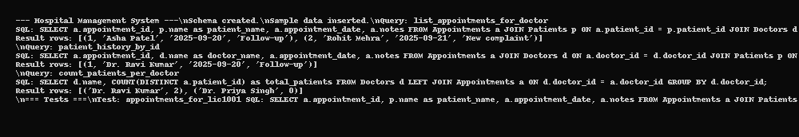

## Task 3: Library Management System

**Schema:**

CREATE TABLE Books (  
 book_id INTEGER PRIMARY KEY AUTOINCREMENT,  
 isbn TEXT UNIQUE NOT NULL,  
 title TEXT NOT NULL,  
 author TEXT,  
 copies INTEGER DEFAULT 1  
);  
CREATE TABLE Members (  
 member_id INTEGER PRIMARY KEY AUTOINCREMENT,  
 name TEXT NOT NULL,  
 member_no TEXT UNIQUE NOT NULL,  
 joined_on DATE  
);  
CREATE TABLE Loans (  
 loan_id INTEGER PRIMARY KEY AUTOINCREMENT,  
 book_id INTEGER NOT NULL,  
 member_id INTEGER NOT NULL,  
 loan_date DATE NOT NULL,  
 return_date DATE,  
 FOREIGN KEY(book_id) REFERENCES Books(book_id),  
 FOREIGN KEY(member_id) REFERENCES Members(member_id)  
);

**Sample Inserts:**

INSERT INTO Books (isbn, title, author, copies) VALUES ('978-0131103627','The C Programming Language','Kernighan & Ritchie',2);

INSERT INTO Books (isbn, title, author, copies) VALUES ('978-0262033848','Introduction to Algorithms','Cormen et al',1);

INSERT INTO Members (name, member_no, joined_on) VALUES ('Mohd Aadil','M001','2024-08-01');

INSERT INTO Members (name, member_no, joined_on) VALUES ('Simran Kaur','M002','2025-01-10');

INSERT INTO Loans (book_id, member_id, loan_date, return_date) VALUES (1,1,'2025-08-01',NULL);

INSERT INTO Loans (book_id, member_id, loan_date, return_date) VALUES (2,2,'2025-07-01',NULL);

**Queries:**

books_currently_issued: SELECT b.title, m.name, l.loan_date FROM Loans l JOIN Books b ON l.book_id = b.book_id JOIN Members m ON l.member_id = m.member_id WHERE l.return_date IS NULL;

find_overdue_books: SELECT b.title, m.name, l.loan_date, JULIANDAY('now') - JULIANDAY(l.loan_date) as days_out FROM Loans l JOIN Books b ON l.book_id = b.book_id JOIN Members m ON l.member_id = m.member_id WHERE l.return_date IS NULL AND JULIANDAY('now') - JULIANDAY(l.loan_date) > 30;

count_books_loaned_by_member: SELECT m.member_no, m.name, COUNT(l.loan_id) as loans FROM Members m LEFT JOIN Loans l ON m.member_id = l.member_id GROUP BY m.member_id;

Index/Normalization suggestions (if any):

Create indexes on Loans(member_id), Loans(book_id), Books(isbn) to speed joins and lookups.

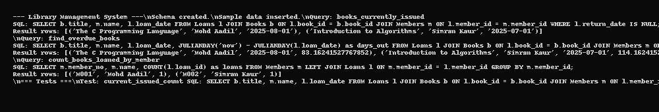

## Task 4: E-commerce Online Shopping

**Schema:**

CREATE TABLE Users (  
 user_id INTEGER PRIMARY KEY AUTOINCREMENT,  
 username TEXT UNIQUE NOT NULL,  
 email TEXT UNIQUE NOT NULL,  
 joined_on DATE  
);  
CREATE TABLE Products (  
 product_id INTEGER PRIMARY KEY AUTOINCREMENT,  
 sku TEXT UNIQUE NOT NULL,  
 name TEXT NOT NULL,  
 price REAL NOT NULL  
);  
CREATE TABLE Orders (  
 order_id INTEGER PRIMARY KEY AUTOINCREMENT,  
 user_id INTEGER NOT NULL,  
 order_date DATE NOT NULL,  
 status TEXT DEFAULT 'PLACED',  
 FOREIGN KEY(user_id) REFERENCES Users(user_id)  
);  
CREATE TABLE OrderDetails (  
 order_detail_id INTEGER PRIMARY KEY AUTOINCREMENT,  
 order_id INTEGER NOT NULL,  
 product_id INTEGER NOT NULL,  
 quantity INTEGER DEFAULT 1,  
 unit_price REAL NOT NULL,  
 FOREIGN KEY(order_id) REFERENCES Orders(order_id),  
 FOREIGN KEY(product_id) REFERENCES Products(product_id)  
);

**Sample Inserts:**

INSERT INTO Users (username, email, joined_on) VALUES ('aadil','aadil@example.com','2025-01-01');

INSERT INTO Users (username, email, joined_on) VALUES ('neha','neha@example.com','2025-02-02');

INSERT INTO Products (sku, name, price) VALUES ('SKU1001','Wireless Mouse',599.0);

INSERT INTO Products (sku, name, price) VALUES ('SKU1002','Mechanical Keyboard',2499.0);

INSERT INTO Orders (user_id, order_date, status) VALUES (1,'2025-09-01','DELIVERED');

INSERT INTO Orders (user_id, order_date, status) VALUES (1,'2025-09-15','PLACED');

INSERT INTO OrderDetails (order_id, product_id, quantity, unit_price) VALUES (1,1,1,599.0);

INSERT INTO OrderDetails (order_id, product_id, quantity, unit_price) VALUES (1,2,1,2499.0);

INSERT INTO OrderDetails (order_id, product_id, quantity, unit_price) VALUES (2,1,2,599.0);

**Queries:**

orders_by_user: SELECT o.order_id, o.order_date, o.status, SUM(od.quantity * od.unit_price) as total_amount FROM Orders o JOIN OrderDetails od ON o.order_id = od.order_id JOIN Users u ON o.user_id = u.user_id WHERE u.username = 'aadil' GROUP BY o.order_id;

most_purchased_product: SELECT p.sku, p.name, SUM(od.quantity) as qty_sold FROM Products p JOIN OrderDetails od ON p.product_id = od.product_id GROUP BY p.product_id ORDER BY qty_sold DESC LIMIT 1;

total_revenue_month: SELECT SUM(od.quantity * od.unit_price) as revenue FROM Orders o JOIN OrderDetails od ON o.order_id = od.order_id WHERE strftime('%Y-%m', o.order_date) = '2025-09';

Index/Normalization suggestions (if any):

Ensure OrderDetails is separate (it is). Consider moving product price history to a ProductPrices table to avoid historical price overwrite.

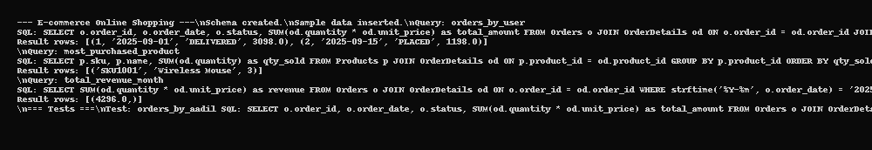

# Updates: Assertions and Analysis

As per assignment requirements, each task now includes at least 3 assert test cases and detailed analysis of test results. The report has been updated accordingly.